**ML METHODS FOR SPAMSMER AND NON-SPAMSMER E- MAIL**

**CLASSIFICATION**

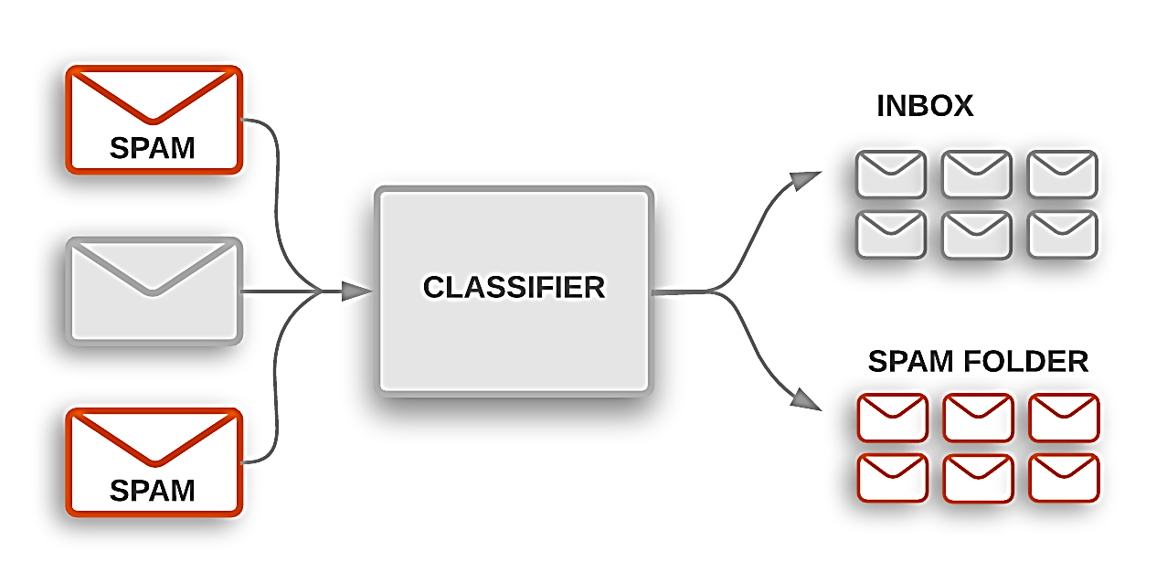

**Abstract**

The expanding volume of spontaneous mass email (otherwise called spams) has created a requirement for reliableanti spams channel. Machine Learing method now days used to consequently channel the spams email in an extremely operative rate. In this paper we audit the absolute most mainstream Machine Learning approaches ( Bayesian N/w, k-nearest neighbors, ANNs, support vector machine, Artificial invulnerable framework ) and of their appropriateness to the problem of spams Email arrangement. Portrayals of the calculation are demonstrated.

1. **Project Info:** As of late unconstrained business/mass email generally called spams, become a significant issue over the web. Spams is pointless activity, additional room and correspondence move speed. The issue of spams email has been growing for a significant period of time. In late estimations, 40% of all messages are spams which about 15.4 billion email for consistently and that cost web customers about $355 million consistently. Modified email isolating is apparently the best procedure for countering spams at this moment and a tight challenge among spammer's and spams-filtering methodologies is going on. Just a serious extended period of time back an enormous part of the spams could be constantly prevailing by blocking messages beginning from explicit areas or filtering through messages with persuaded titles. Spammer's begun to use a couple of questionable procedures to vanquish the isolating methods like using discretionary sender locations or theoretically connect sporadic characters to the beginning or the piece of the planning title. Data structuring and AI are the two general techniques used in email filtering. In getting the hang of structuring strategy a great deal of principles must be resolved agreeing to which messages are arranged as spams or ham. A great deal of such standards should be made either by the customer of the channel, or by some other expert (for instance the item association that gives a particular rule based spams-isolating contraption). By applying this technique, no promising results shows up since the standards must be constantly invigorated and kept up, which is a pointless activity and it isn't useful for the most part customers. Artificial intelligence approach is more capable than getting the hang of planning technique; it doesn't require deciding any standards . Or maybe, a great deal of getting ready tests, these models is a ton of pre assembled email messages. A specific computation is by then used to take in the gathering rules from these email messages. ML approach has been by and large examined and there are heaps of computations can be used in email isolating. They incorporate Naïve Bayes, SVM(Support vector machines), Neural Networks, K-nearest neighbor, arbitrary woodland calculation and the fake safe system.

**Objective:** The goal of this project is to test different classification and supervised machine learning algorithms that might hypothetically be used as spamss filter in the Email . Fundamentally we want to see which algorithms have the best chance to predicting a spams email in given certain-criteria.

**MACHINE-LEARNING IN E-MAILS CLASSIFICATION:** Machine-Learning (ML) field is a subfield from the wide field of man-made cognizance, this expects to prepare machines to learn like human. Learning here techniques fathomed, watch and address information about some accurate marvel. In independent learning one endeavors to uncover covered regularities (bundles) or to perceive peculiarities in the data like spams messages or framework interference. In email filtering task a couple of features could be the pack of words or the title examination. Consequently, the commitment to email course of action task can be viewed as a two dimensional system, whose tomahawks are the messages and the features. Email request tasks are every now and again parceled into a couple of sub-assignments. In any case, Data social affair and depiction are generally issue express (for instance email messages), second, email incorporate decision and feature lessening try to reduce the dimensionality (for instance the amount of features) for the remainder of the methods for this venture.

**We have follow the following steps to perform the email –classification:**

**1: Import data set and installed all required packages in R studio:**

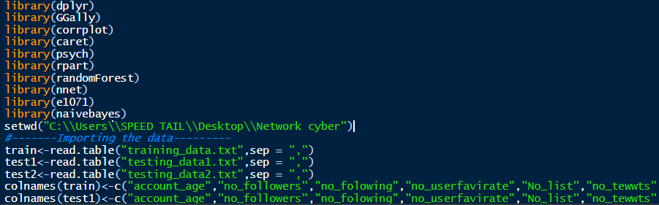

**2. Then perform the Explanatory data analysis:**

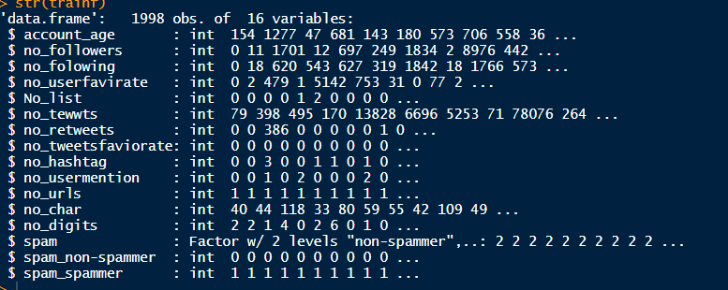

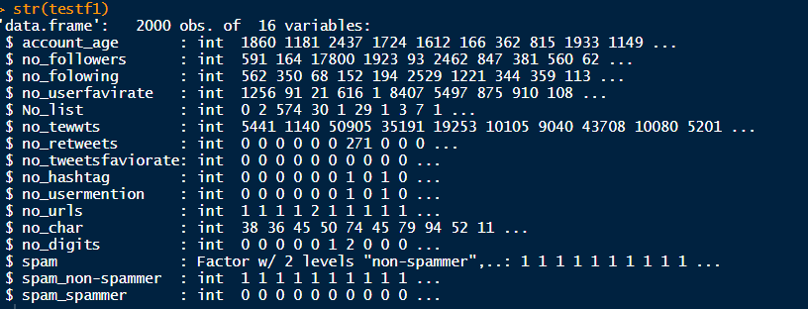

**We have only spams variable that is factor data type**, **and other are integers:**

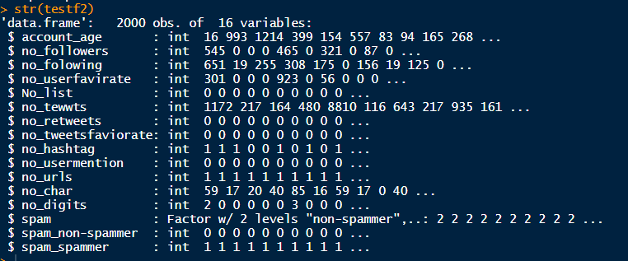

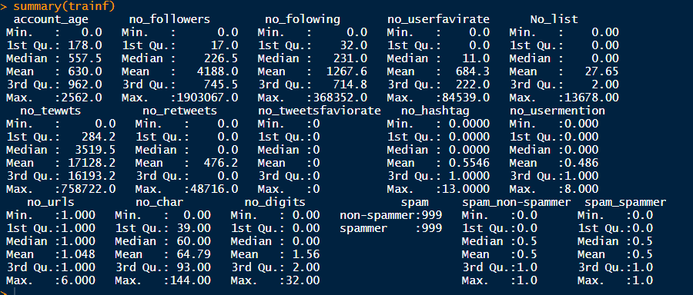

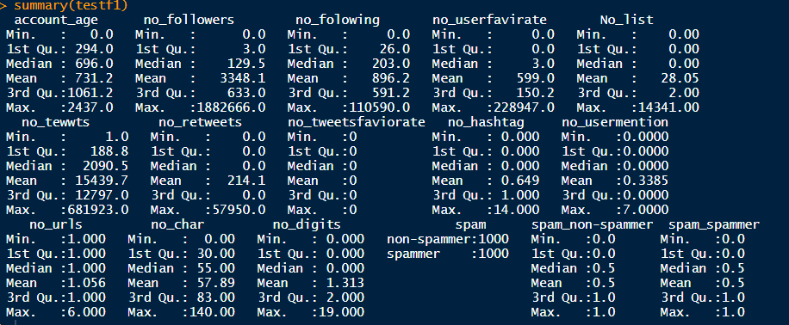

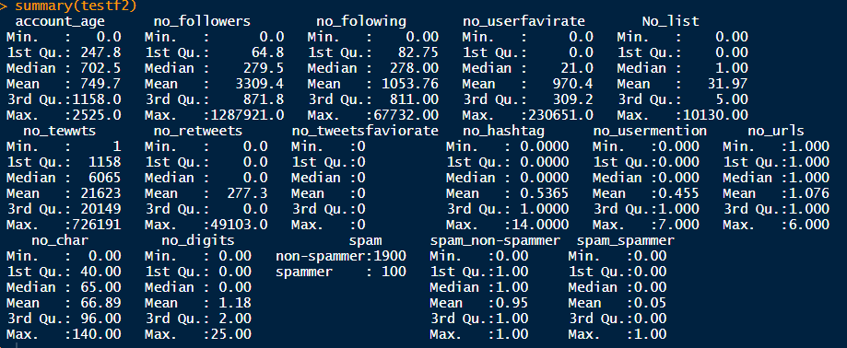

**Data set has cleaned, here none of missing values:**

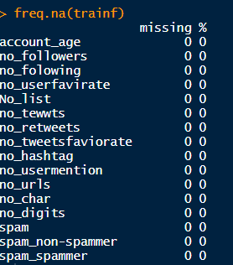

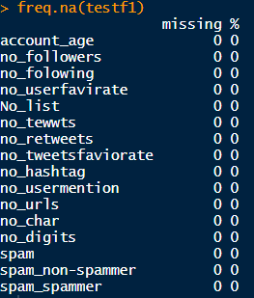

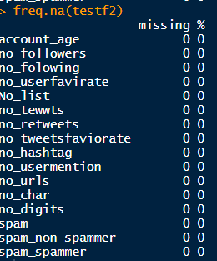

**By using table function we have analysis that 5% email are spams in testing table2 dataset:**

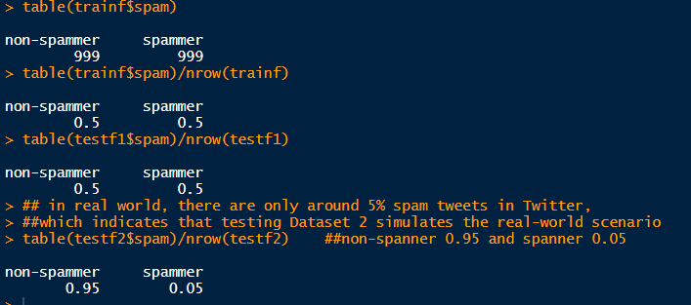

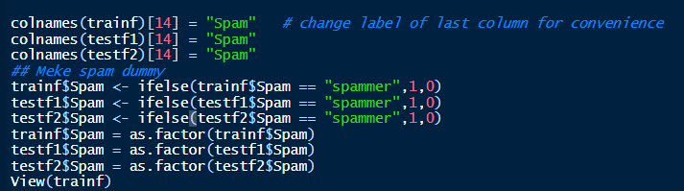

**Training the Models:** After some-research we have decided to test the Random Forest and Neural –Networks. These algorithm required the least tunings and is designed to work with the categorical data. These algorithms are disguised from their respective package and used with caret’s training -function. The training control method used is repeated cross-validation. 10 separate 10 fold cross over are used to mend model accuracy. Have use nnet library in R to perform the model.

We have set up the training-control. The trainings control method repeated the cross validations. We have use 10 separate 10 fold cross overs are used to improve model the model accuracy.

**Machine-Learning and classification model:-**

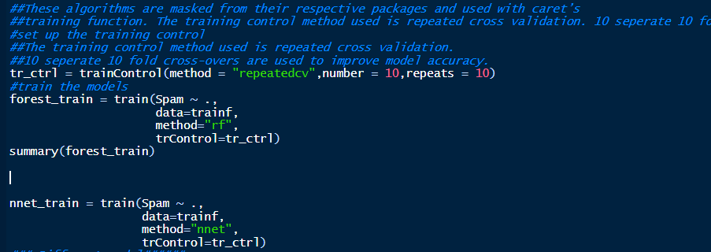

**We have perform the random forest and Neural network :**

**Random forest Output:**

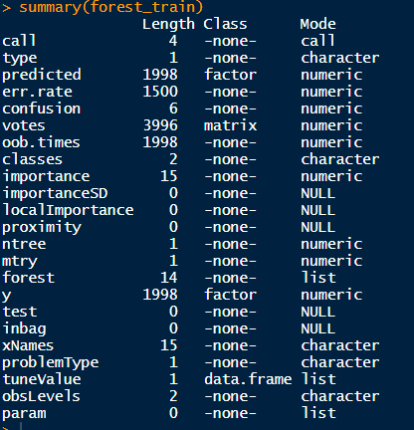

**Result:** Now that the model are trained we test them against the testing set.

The confusion Matrix () display the result and relevant-statistics for each-model.

**Confusion-Matrix for Random-forest Model: We got 100% accuracy.**

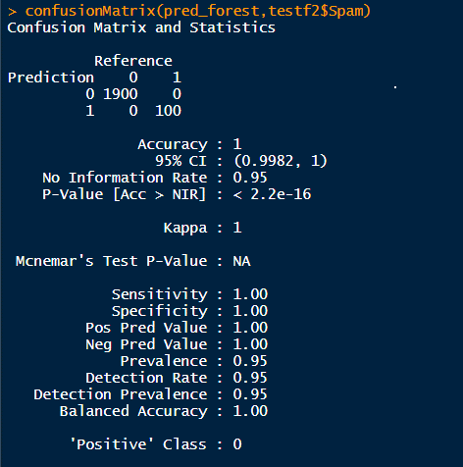

**Confusion-Matrix for Neural-Network: we got 91% model accuracy**

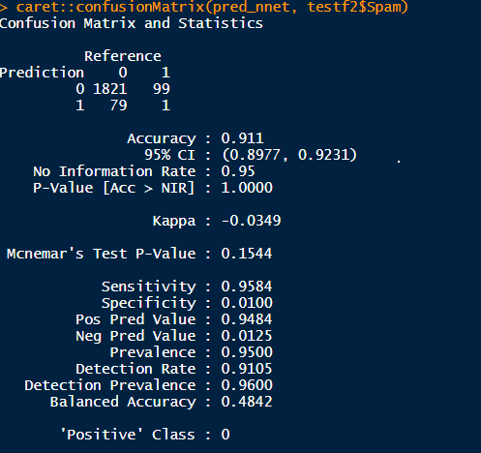

**Classification RPart (Recursive Partitioning and Regression Trees) Algorithm:**

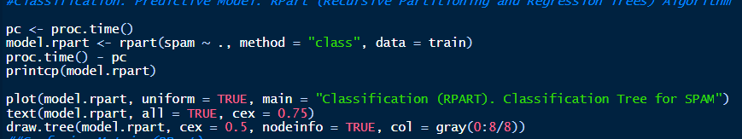

**Classification Tree for Email (non spamsmer)-SPAMS:**

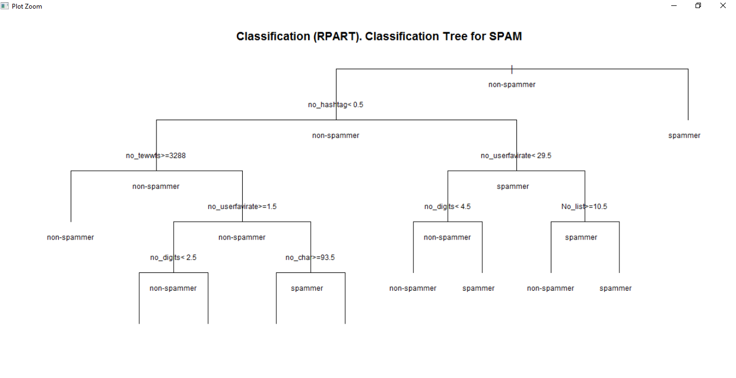

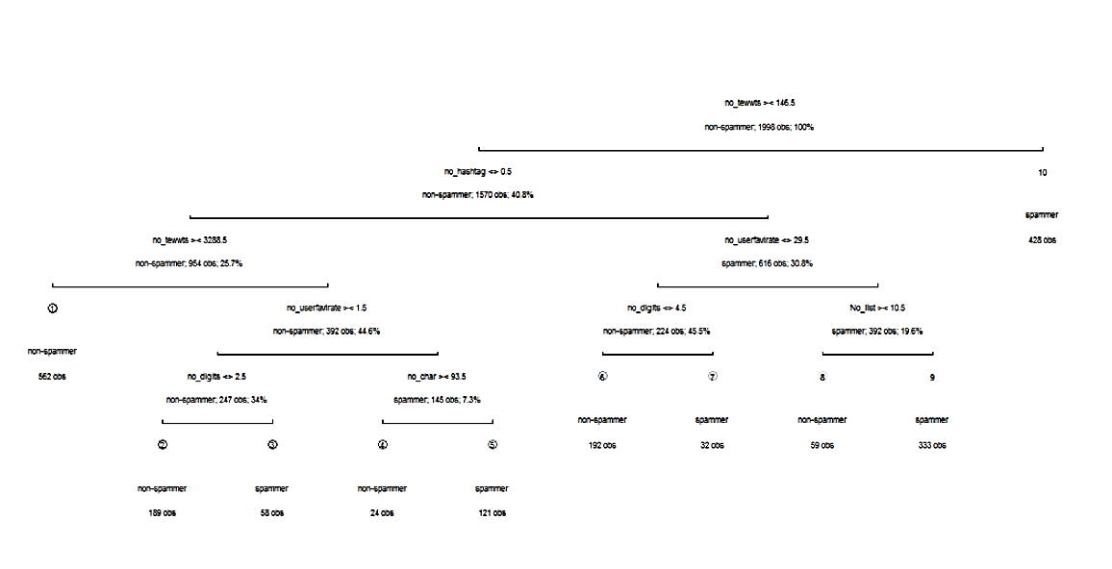

table(`Actual Class` = test2$spams, `Predicted Class` = prediction.rpart)

Predicted Class

Actual Class non-spamsmer spamsmer

non-spamsmer 1464 436

spamsmer 30 70

> error.rate.rpart <- sum(test2$spams != prediction.rpart)/nrow(test2)

> print(paste0("Accuary (Precision): ", 1 - error.rate.rpart))

[1] "Accuary (Precision): 0.767"

**We got 76% accuracy .**

With this-sample, Random-Forest model seemed to performed the best with 100% accuracy and Neural-Networks model performed slightly-lower , have got 91% accuracy but with fine-tuning the result would most likely improved.

**Random-Forest Classifier:** We have used random forest classifier to classify the Spams. Random Forest model is method to do arrangements dependent on highlights. This infers you need highlights and orders. Random-Forest model generates a lot of characterization trees (a troupe) in light of parting a subset of highlights at areas which augment data gain. This strategy is along these lines truly reasonable for disseminated parallel calculation.

Data addition can be controlled by how exact the parting point is in deciding the characterization. Information is part founded on the element at a particular point and the characterization on the left and right of the parting point are checked. On the off chance that for instance the parting point parts all information of a first order from all information of a subsequent grouping, the certainty is 100%; most extreme data gain.

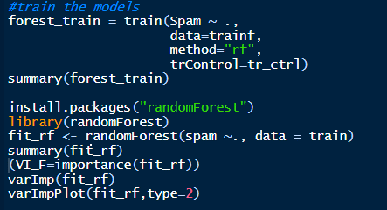

**Random forest Model Summary:**

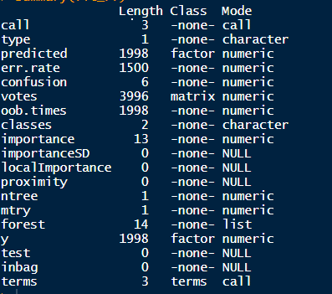

**FeatureImportance We have found by using Random forest classifier** :

> varImp(fit_rf)

Overall

account_age 105.012981

no_followers 119.133972

no_folowing 96.111533

no_userfavirate 78.090408

No_list 64.312603

no_tewwts 160.054259

no_retweets 34.287561

no_tweetsfaviorate 0.000000

no_hashtag 113.802207

no_usermention 23.919947

no_urls 6.936656

no_char 110.178964

no_digits 65.188742

**Feature Importance Plot by random Forest:**

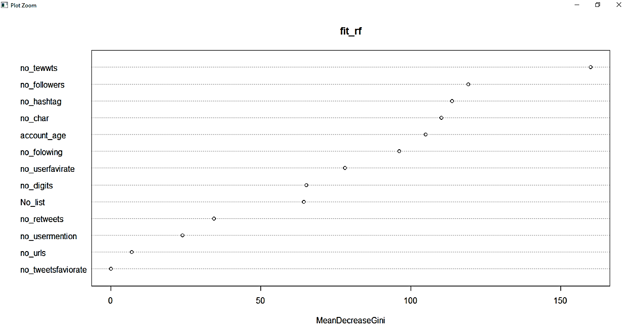

**Visualization for SPAMS Data: here 0 is spams and 1 is non-spamsmer**

**No_age distribution by Spams:**

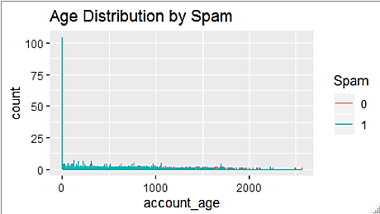

**No-followers distribution by Spams:**

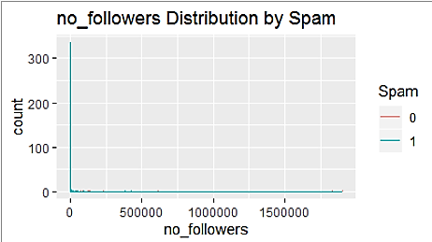

**No _user favorite distribution by Spams:**

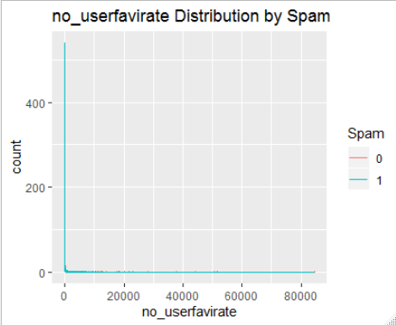

**No_foloowers distribution by Spams:**

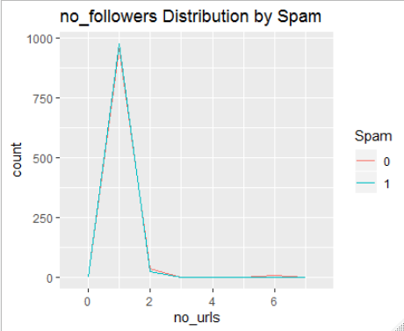

**No_urls distribution by Spams:**

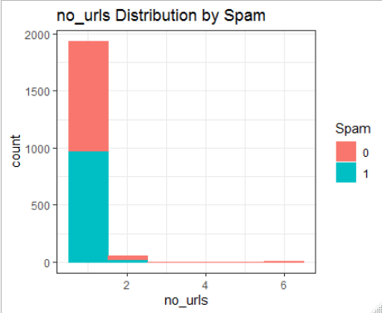

**No-digits distribution by Spams:**

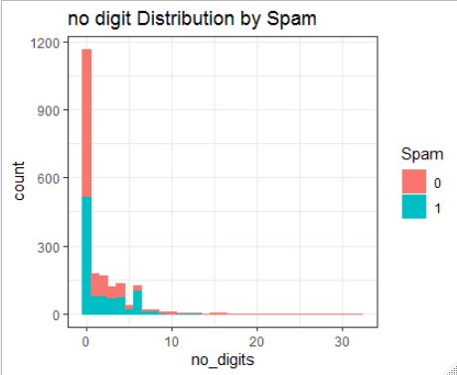

**No_char distribution by Spams:**

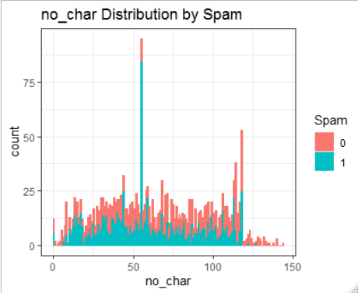

**No_hashtag distribution by Spams:**

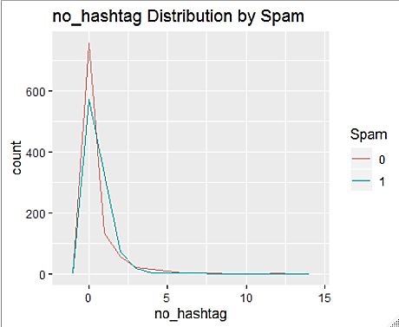

**Plot of Train data :**

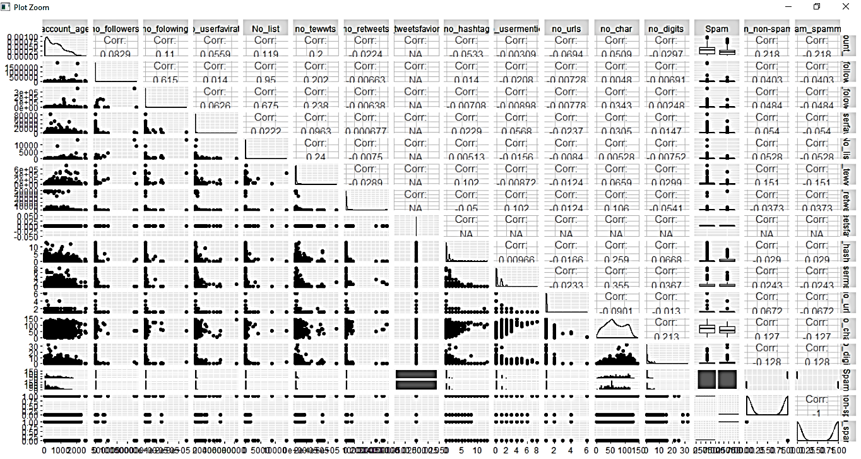

**In train dataset Spams-percentage: Here email -** **non-spamsmer**

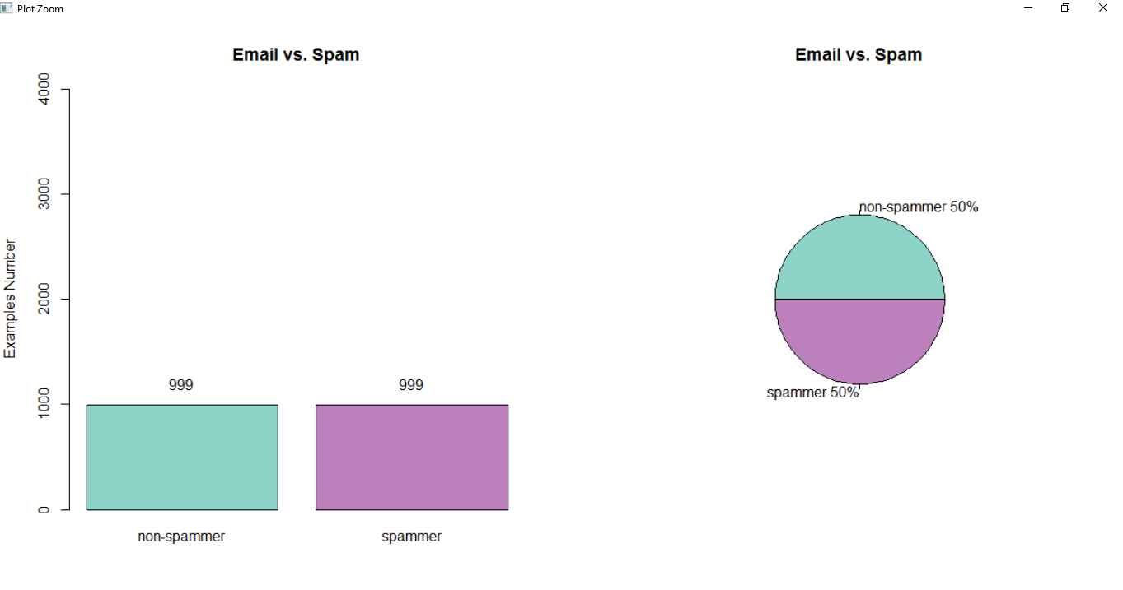

**Spams: Average-Percentage in the data:**

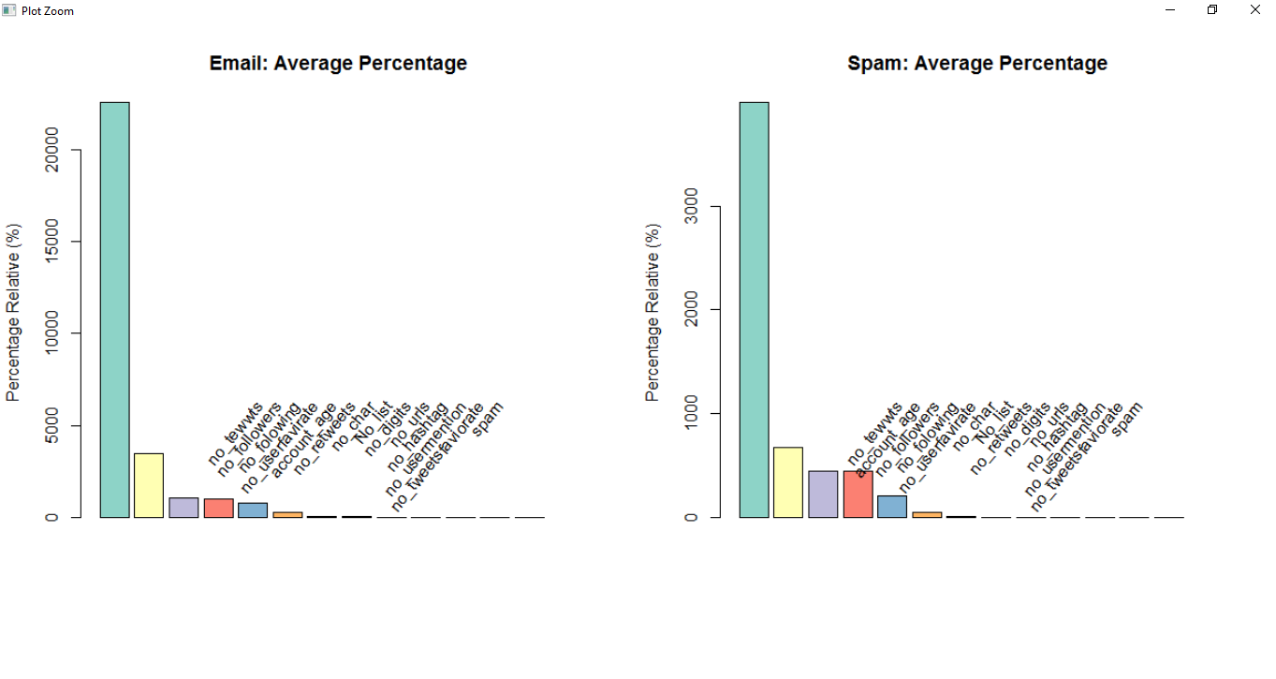

**Email**(**non-spamsmer**)  **vs. Spams (Training-Data Set):**

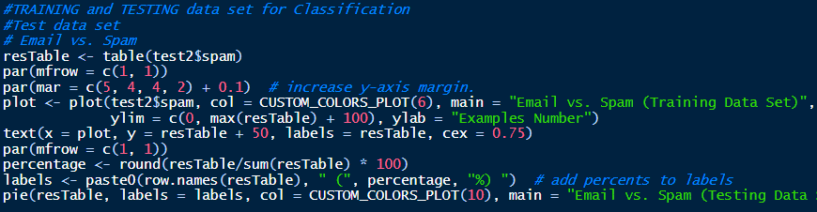

**In Test table 2:**

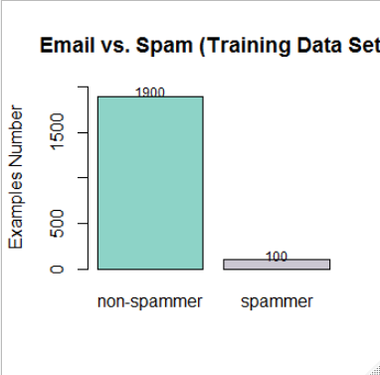

**Email (non-spamsmer) vs. Spams (Testing Data Set):**

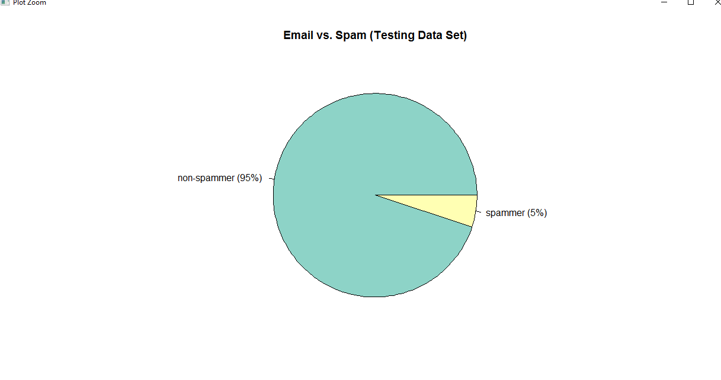

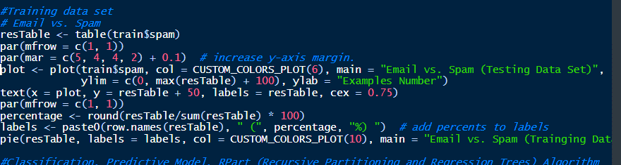

**In Train-data set:**

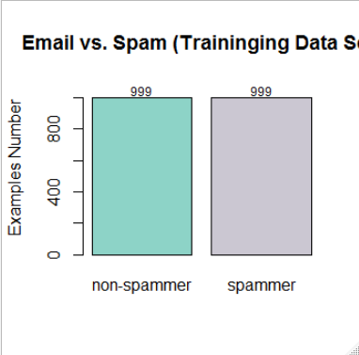

**Pie Chart for Email (non-spamsmer) and Spams:**

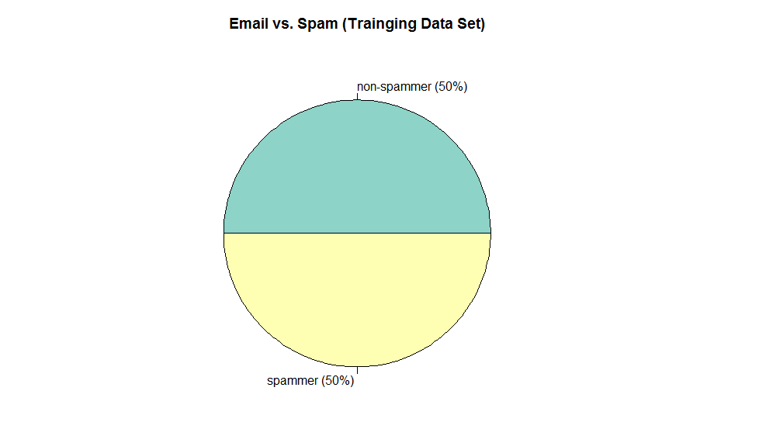

**Naïve-Bayes Machine-Learning classifier method:**

In 1998 the NaïveBayes classifier was projected for spams acknowledgment. Bayesian-classifier is taking a shot at the needy occasions and the likelihood of an occasion happening later on that can be recognized from the past happening of a similar occasion . Guileless Bayes is a generative grouping technique that depends on Bayes hypothesis. It computes the earlier probabilities of each class and probabilities of each quality in each class. It accept that the probabilities of each quality are free of one another. At the hour of order it utilizes the earlier probabilities of each class and the probabilities of the watched traits. The class with most astounding likelihood is relegated to the case being characterized. This method can be utilized to characterize spams messages; words probability play the primary standard here. On the off chance that a few word occur regularly in spams yet not in ham, at that point this approaching email is likely spams. Innocent bayes classifier procedure has turned into a mainstream strategy in mail sifting programming. Bayesian channel ought to be prepared to work adequately. Each word has certain likelihood of happening in spams or ham email in its database. In the event that the aggregate of words probabilities surpasses a specific farthest point, the channel will check the email to either classification. Here, just two classifications are essential: spams or ham. Practically all the measurement based spams channels utilize Bayesian likelihood figuring to join singular token's insights to a general score , and settle on separating choice dependent on the score. The measurement we are for the most part intrigued for a token T is its spamsmers , determined as pursues:

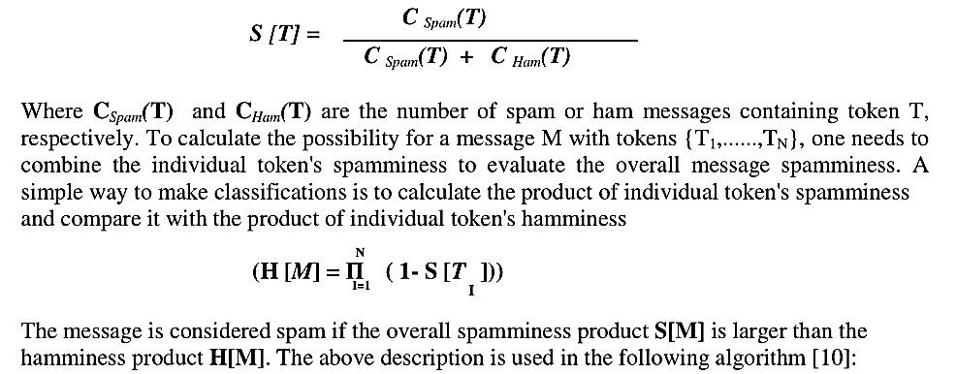

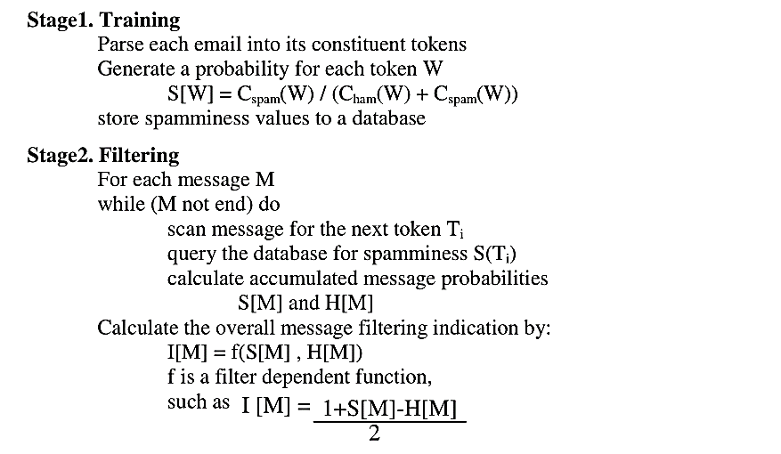

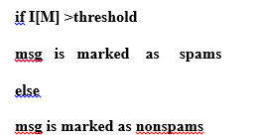

**Naïve0Bias Model:**

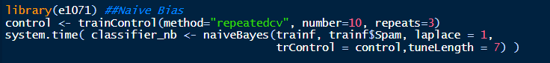

**Now Making Predictions and evaluating the NaiveBayes Classifier:**

Confusion Matrix and Statistics

Reference

Prediction 0 1

0 1894 0

1 6 100

Accuracy : 0.997

95% CI : (0.9935, 0.9989)

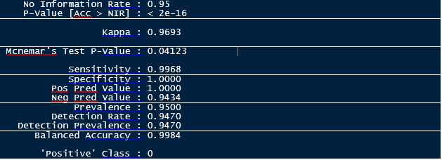

The Naïve-Bayes Classifier also performed-very well on the-training set by achieve 99.70% accuracy which-means we got misclassifications out possible remark. While the model has a 100% sensitivity rate; the proportions of the positive class predicted as positive, it was able to achieve about 100% on specificity which is the proportions of the negative class predicted accurately

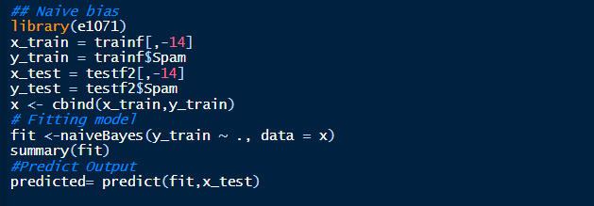

**By using naïve Bias We have got best ever accuracy : 99%**



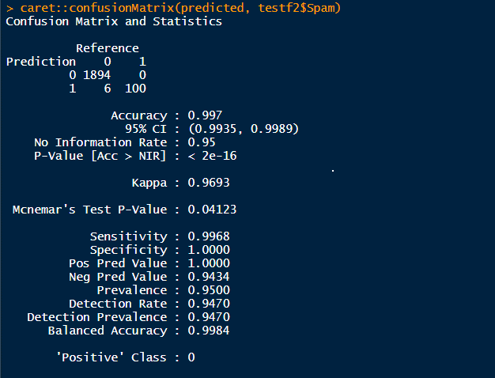

**By using Naïve Bias we have got 99% accuracy.**

**###Model-Evalution for naïve Bias Machine Learning Model:**

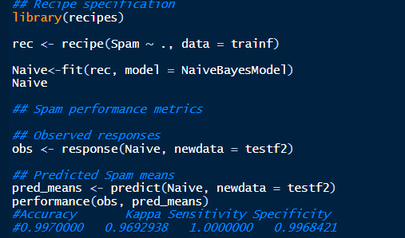

**Artificial-Neural Networks classifier method:** An artificial-neural-network (ANN) is computational-model dependent on natural-neural system. It comprises of an interconnected gathering of counterfeit neurons. A fake neural system is a versatile framework that changes its structure dependent on data that moves through the fake system during a learning stage. The ANN depends on the guideline of learning by model. There are, anyway the two old style sort of the neural systems, perceptron and the multilayer-perceptron.

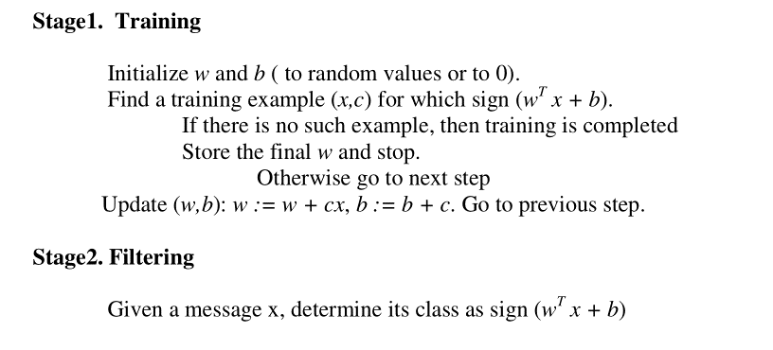

**Neural N/w Machine0Learning Model:**

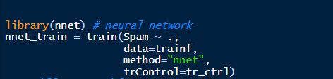

**Model result: We have got 91% accuracy Neural N/w model for Email spams detection**



**For test data 1 We have got less accuracy: got 49.5% accuracy**

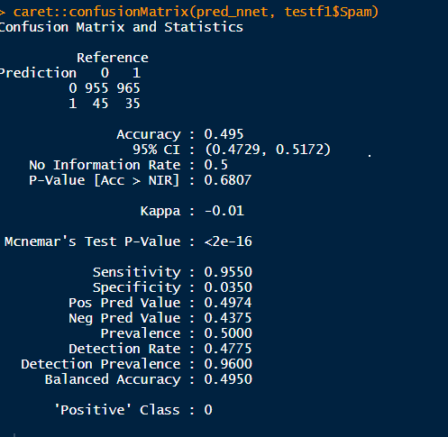

Neural-Networks performed slightly lower , we got 91% accuracy but with fine tuning the results would most likely improve.

**Support-Vector Machines-classifier Model:**

SVM rely upon the possibility of decision planes that portray decision limits. A decision plane is one that disconnects between a ton of articles having assorted class enlistments, the SVM demonstrating calculation finds an ideal hyper plane with the maximal edge to isolate two classes, which requires taking care of the accompanying advancement issue. SVM is a discriminative regulated AI system of grouping. SVM applies0Vapnik's measurable learning hypothesis to prepare classifiers. SVM has some striking highlights for which it has been considered as condition of craftsmanship in the grouping undertakings. SVM has been utilized for content order, written by hand digit location and numerous other characterization errands. A portion of its one of a kind highlights are: it can function admirably in an exceptionally high dimensional element space, it exploit just a subset of unique preparing set to settle on choice limit called bolster vector and it is likewise appropriate for non-directly detachable information (it utilizes piece stunt).

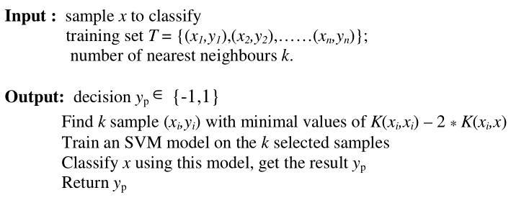

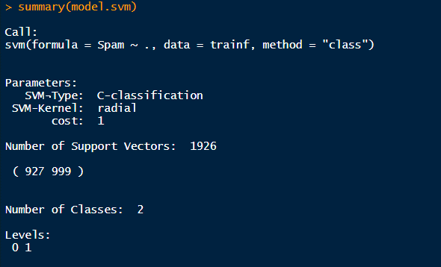

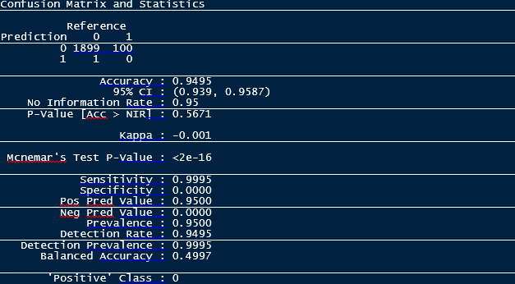

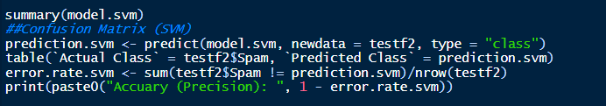

We got 94% accuracy by SVM.

By using linear kernel we have build SVM model:

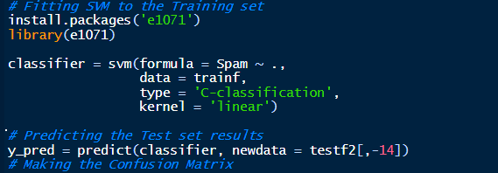

We have again perform the SVM model then we have got this result:

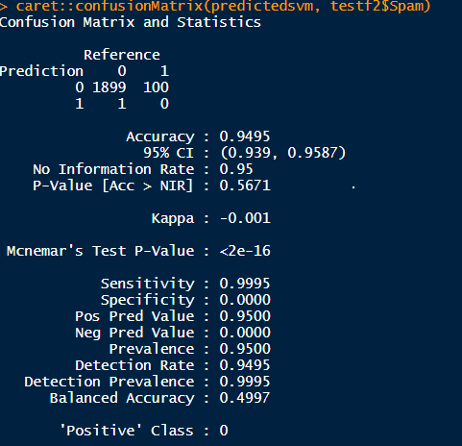

Confusion Matrix For SVM:

> conf_matrix

predictions

targets 1 2

1 1552 82

2 348 18

**SVM (Support Vector Machine) Algorithm:**

**Output:**

svm(formula = spams ~ ., data = train, method = "class")

Parameters:

SVM-Type: C-classification

SVM-Kernel: radial

cost: 1

Number of Support Vectors: 1928

( 929 999 )

Number of Classes: 2

Levels:

non-spamsmer spamsmer

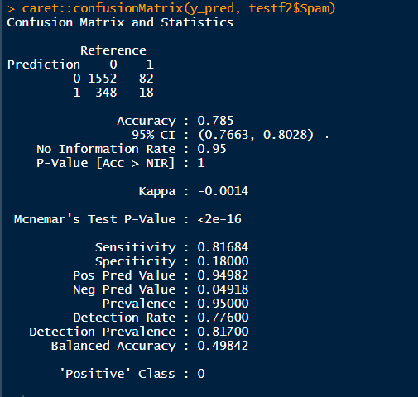

We have got less accuracy by using SVM , got 78%

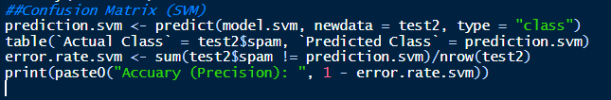

print(paste0("Accuary (Precision): ", 1 - error.rate.svm))

[1] "Accuary (Precision): 0.9495"

We have goted 94% Precisian accuracy

**Performance-Comparison:** NaïveBayes system has the most surprising accuracy among the six Calculations while the kNN neighbor has the most perceptibly dreadful precision rate and amazingly the cruel sets procedure has an incredibly forceful percent, finally we can find that the audit is the less rate among the six classifiers while the Naïve Bayes still has the most astonishing execution anyway saw as low when appeared differently in relation to precision and exactness while the upsetting sets has the most exceedingly horrible introduction.

**Validity of the-model:**

The essence of building the spams classifier is for the model to be able to effectively categories an incoming email as either spamsmer or non-spamsmer. The Random Forest and Naive Bayes performed exceptionally well in this project.

**CONCLUSION:** In Email-Spam classification project we scrutinize the absolute most protuberant Machine-learning techniques and of their materialness to the issue of spams email characterization. Email spams order has gotten a huge consideration by lion's share of the individuals as it recognizes the undesirable data and dangers. Thusly, the greater part of the analysts focus in finding the best classifier for distinguishing spams messages. We can discovery that the Naïv- bayes and harsh sets techniques has an exceptionally fulfilling exhibition among different strategies, more research must be done to raise the presentation of the Naïve-bayes and Artificial resistant framework either by crossover framework or by purpose the component reliance issue in the gullible bayes classifier, or half and half the Immune by unpleasant sets. At long last half and half frameworks seem to be the most productive approach to create a antispams channel these days.

**References**

* Meda, C., Bisio, F., Gastaldo, P. and Zunino, R., 2014, October. A machine learning approach for Twitter spammer’s detection. In 2014 International Carnahan Conference on Security Technology (ICCST) (pp. 1-6). IEEE.
* Song, J., Lee, S. and Kim, J., 2011, September. Spams filtering in twitter using sender-receiver relationship. In International workshop on recent advances in intrusion detection (pp. 301-317). Springer, Berlin, Heidelberg.
* Tan, E., Guo, L., Chen, S., Zhang, X. and Zhao, Y., 2012, June. Spamsmer behavior analysis and detection in user generated content on social networks. In 2012 IEEE 32nd International Conference on Distributed Computing Systems (pp. 305-314). IEEE.
* Ye, Q., Zhang, Z. and Law, R., 2009. Sentiment classification of online reviews to travel destinations by supervised machine learning approaches. Expert systems with applications, 36(3), pp.6527-6535.
* Chen, J., Huang, H., Tian, S. and Qu, Y., 2009. Feature selection for text classification with Naïve Bayes. Expert Systems with Applications, 36(3), pp.5432-5435.
* Bijalwan, V., Kumar, V., Kumari, P. and Pascual, J., 2014. KNN based machine learning approach for text and document mining. International Journal of Database Theory and Application, 7(1), pp.61-70.